**Probability Models in Electrical and Computer Engineering**

* **Probability models are one of the tools that enable the designer to make sense out of the chaos and to successfully build systems that are efficient, reliable, and cost effective.**

**MATHEMATICAL MODELS AS TOOLS IN ANALYSIS AND DESIGN**

* A **model** is an approximate representation of a physical situation. A model at­tempts to explain observed behavior using a set of simple and understandable rules.
* These rules can be used to predict the outcome of experiments involving the given physical situation. A *useful* model explains all relevant aspects of a given situation. Such models can be used instead of experiments to answer questions regarding the given situation.
* **Models therefore allow the engineer to avoid the costs of experimenta­tion, namely, labor, equipment, and time.**
* **Mathematical models** are used when the observational phenomenon has measur­able properties.
* A mathematical model consists of a set of assumptions about how a system or physical process works. These assumptions are stated in the form of mathe­matical relations involving the important parameters and variables of the system.
* The conditions under which an experiment involving the system is carried out determine the "givens" in the mathematical relations, and the solution of these relations allows us to predict the measurements that would be obtained if the experiment were performed.

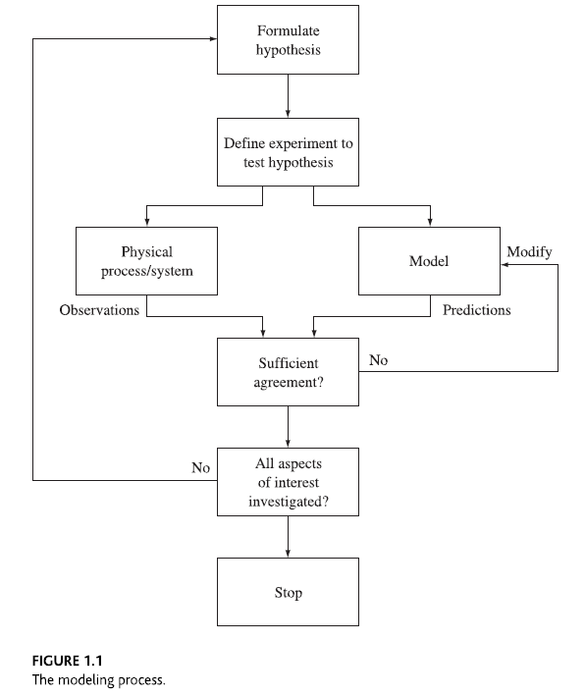

**DETERMINISTIC MODELS**

* **In deterministic models the conditions under which an experiment is carried out deter­mine the exact outcome of the experiment.**
* In deterministic mathematical models, the solution of a set of mathematical equations specifies the exact outcome of the experi­ment.
* Circuit theory is an example of a deterministic mathematical model.
* If an experiment involving the measurement of a set of voltages is repeated a number of times under the same conditions, circuit theory predicts that the observa­tions will always be exactly the same.
* Nevertheless, this deterministic model will be adequate as long as the deviation about the predicted val­ues remains small.

**PROBABILITY MODELS**

* Many systems of interest involve phenomena that exhibit unpredictable variation and randomness.
* **We define a random experiment to be an experiment in which the out­come varies in an unpredictable fashion when the experiment is repeated under the same conditions.**
* **Deterministic models are not appropriate for random experiments since they predict the same outcome for each repetition of an experiment. In this sec­tion we introduce probability models that are intended for random experiments.**
* As an example of a random experiment, suppose a ball is selected from an urn containing three identical balls, labeled 0,1, and 2. The urn is first shaken to random­ize the position of the balls, and a ball is then selected.
* The number of the ball is noted, and the ball is then returned to the urn. The **outcome** of this experiment is a number from the set ***S*** = {0,1,2}. We call the set ***S*** of all possible outcomes the **sample space.** Figure 1.2 shows the outcomes in 100 repetitions (trials) of a computer simulation of this urn experiment. It is clear that the outcome of this experiment cannot consistent­ly be predicted correctly.

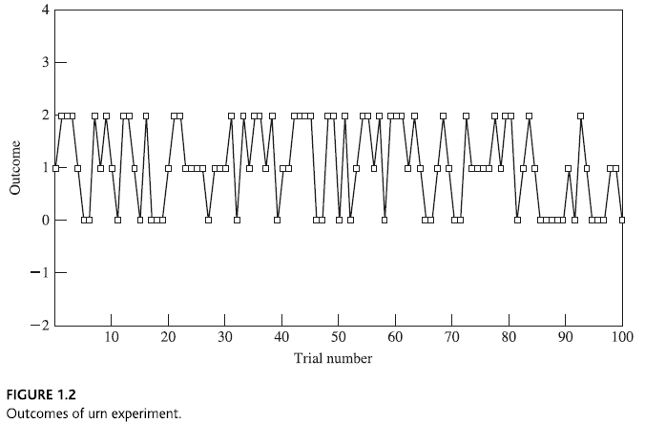

**The Axiomatic Approach to a Theory of Probability**

* The modern theory of probability begins with a construction of **a set of axioms** that specify that probability assignments must satisfy these properties.
* It supposes that:

1. **a random experiment has been defined, and a set S of all possible outcomes has been identified;**
2. **a class of subsets of S called events has been specified; and**
3. **each event A has been assigned a number, , in such a way that the following axioms are satisfied:**

**1. **

**2. **

**3. If A and B are events that cannot occur simultaneously, then **

**Ch 2 Basic Concepts of Probability Theory**

* Set theory
* The axioms of probability
* Notion of conditional probability
* Sequential random experiments

**2.1 SPECIFYING RANDOM EXPERIMENTS**

* **A random experiment is an experiment in which the outcome varies in an unpre­dictable fashion when the experiment is repeated under the same conditions.**
* ***A ran­dom experiment is specified by stating an experimental procedure and a set of one or more measurements or observations.***

**2.1.1 The Sample Space**

* We define an **outcome or sample point** of a ran­dom experiment as a result that cannot be decomposed into other results.
* When we perform a random experiment, one and only one outcome occurs. Thus outcomes are mutually exclusive in the sense that they cannot occur simultaneously.
* The **sample space S** of a random experiment is defined as the set of all possible outcomes.
* We will denote an outcome of an experiment by, where  is an element or point in *S.*
* Each performance of a random experiment can then be viewed as the selection at random of a single point (outcome) from *S.*
* The sample space *S* can be specified compactly by using set notation. It can be visu­alized by drawing tables, diagrams, intervals of the real line, or regions of the plane. There are two basic ways to specify a set:

1. ***List all the elements, separated by commas, inside a pair of braces:***

,

1. ***Give a property that specifies the elements of the set:***

.

* **Note that the order in which items are listed does not change the set, e.g., {0,1, 2, 3} and {1, 2, 3, 0} are the same set.**

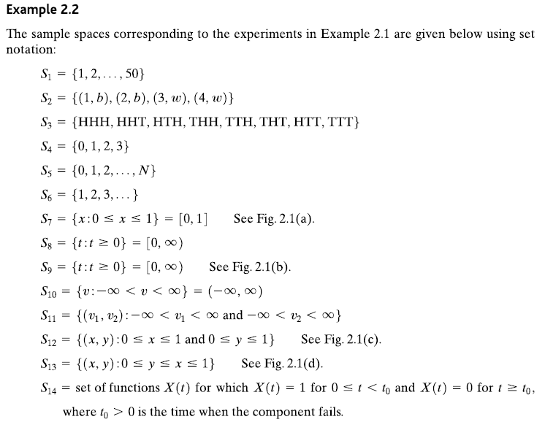

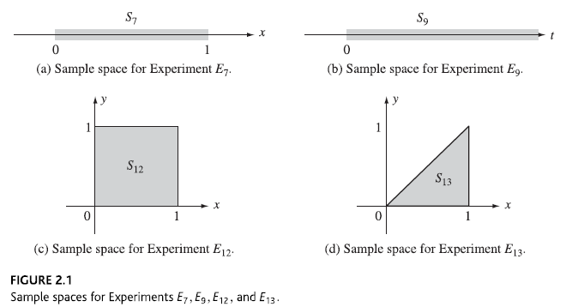

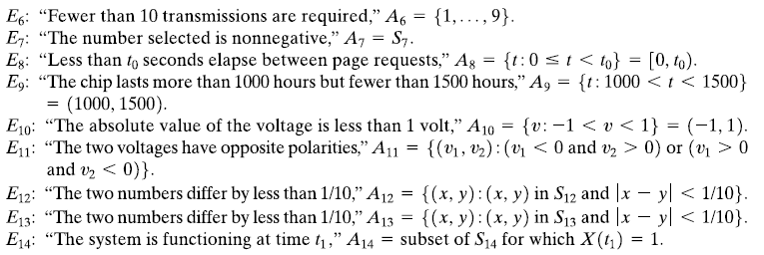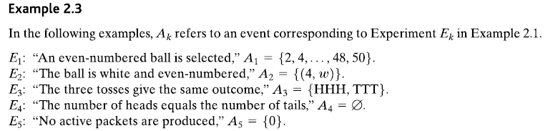

**2.13 Review of Set Theory**

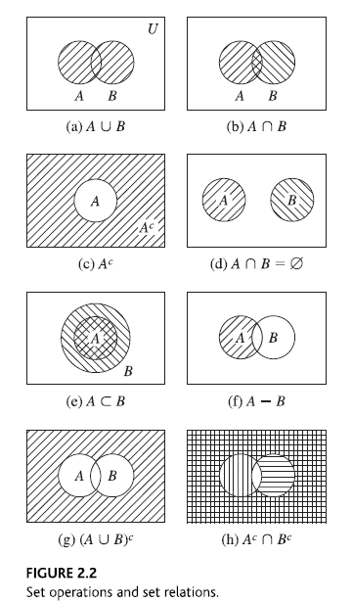

* The **empty set** 0 is defined as the set with no elements.
  + The empty set 0 is a sub­set of every set, that is, for any set *A,*
* We say sets *A* **and** *B* **are equal** if they contain the same elements.

*A* = *B* if and only if **and*.*

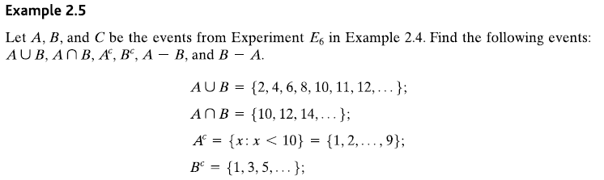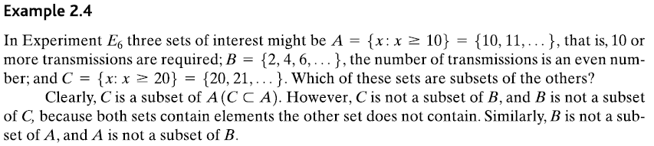

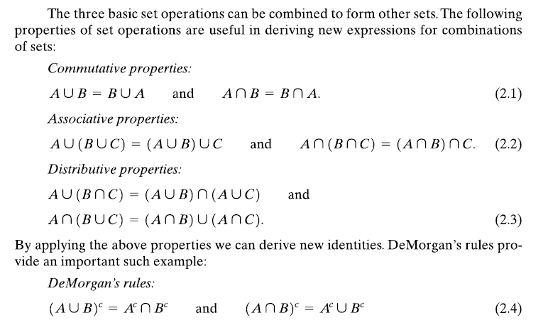

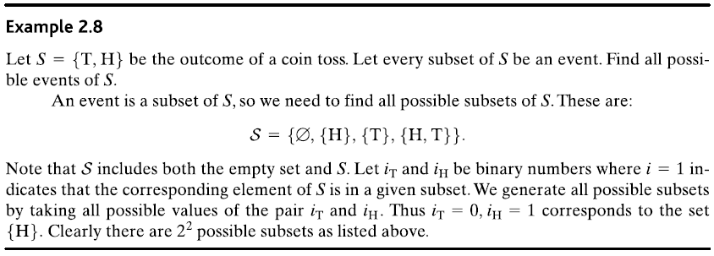

**THE AXIOMS OF PROBABILITY**

